**Lab Exception (Day-11)**

**1.Write a Python program to handle a ZeroDivisionError exception when dividing a number by zero.**

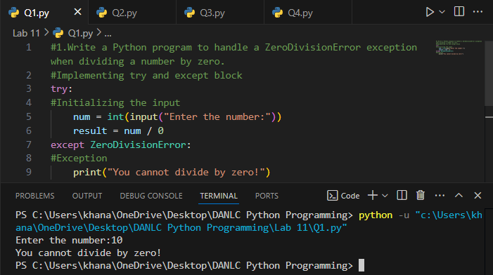

**2.Write a Python program that prompts the user to input an integer and raises a ValueError exception if the input is not a valid integer.**

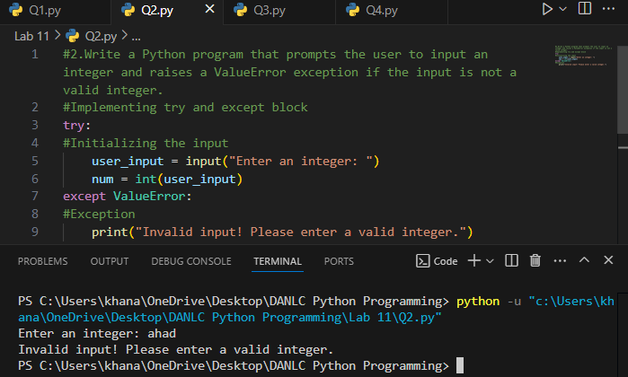

**3. Write a Python program that opens a file and handles a FileNotFoundError exception if the file does not exist.**

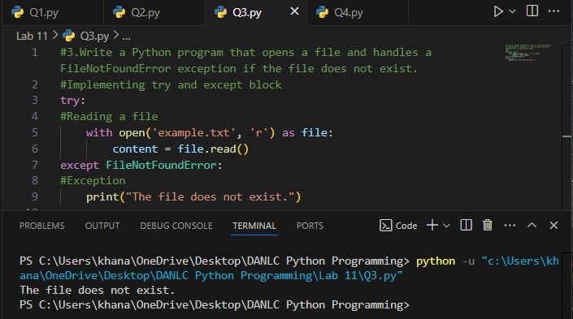

**4.Write a Python program that prompts the user to input two numbers and raises a TypeError exception if the inputs are not numerical.**

